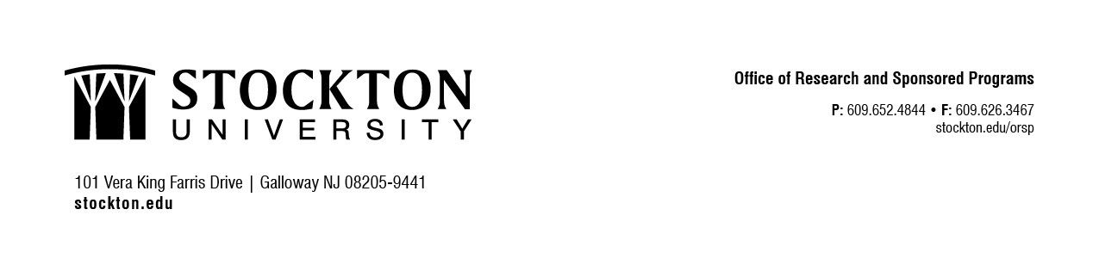

CONFIDENTIAL CONFIDENTIAL CONFIDENTIAL CONFIDENTIAL

Research Participant Receipt Form (RPRF)

Stockton University is required to maintain the confidentiality of information about research study participants while still complying with record keeping requirements of the State of New Jersey, the Internal Revenue Service (IRS), and funding agencies. The purpose of this form is to serve as documentation of the receipt of compensation associated with participation associated with participation in a research study conducted by Stockton University personnel.

I, , have received compensation in the form and amount
(Print Research Participant Name) indicated below:

Cash $ Gift Cards

Research Participant Signature Date

NOTE: Research participants may be given the opportunity to participate without receiving payment if they
choose not to complete this receipt form.

