1. Go to Stockton.edu/zoom and click login
2. Login with their Stockton GoPortal credentials
3. Open the link to the meeting, but rather than open with the zoom app use the join by browser button…

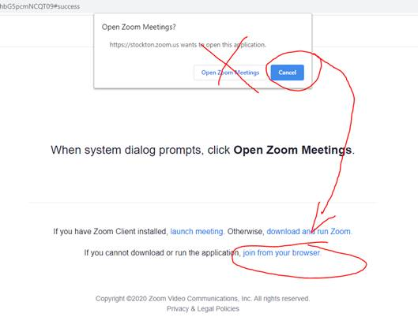

1. That will then join you to the meeting, authenticated, using your formal first + last name that we have for you in the Stockton system.