SOCIAL WORK PROGRAM
DIVERSITY SPEAKERS’ SERIES
Saturday, Feb. 4 @11 AM
Fannie Lou Hamer Event Room, AC Stockton Campus
The Climate Reality Project: Race and Health
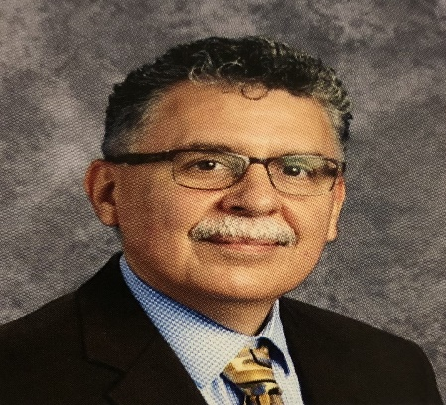
Speaker: Dr. Al Morales
Dr. Al Morales is a Climate Reality Leadership Corps Volunteer trained nationally to help solve climate crisis confronting our global and local environments. Dr. Al Morales is a former science educator and a current public-school administrator. A call to action is proposed to find enduring and immediate solutions to address this urgent issue. Implications to social work practice will be discussed through the participation of social work students.
FOR MORE INFORMATION, CONTACT DR. GUIA CALICDAN-APOSTLE @ Guia.Calicdan-Apostle@stockton.edu

